1. Lesson Recap

* This week, I learned concepts of StatefulSets, ReplicaSets and how normal Deployment & StatefulSets are different from one another (reflected through lab activities).
* In addition, I learned how to “cheat” in writing .yaml file for deploying a container through the including of dry-run in both “kubectl create deployment …” and “kubectl create service …”.
* Revisit on how to “applying for” PVC & checking local files and display its contents.

2. Lab Activities

Followed instruction steps before attempted on Task 1:

* Created 3 container images (node-web:1, 2, and 3) & pushed them to localhost repository.
* Deployed 3 replicas of node-web:1 along with service that governing these latters.

Task 1 – Verify that these objects are related

“kubectl describe deployment node-web”

“kubectl describe replicasets node-web-9cdb67f55”

“kubectl describe pod node-web-9cdb67f55-56gtf”

* All 3 of them were labeled as “app=node-web”
* In “deployment” output, I saw the following line: “NewReplicaSets: node-web-9cdb67f55 (3/3 replicas created)”.
* In “replicasets” output, I saw the line: “Controlled by: Deployment/node-web”.
* In “pod” output, I saw the line: “Controlled by: ReplicaSet/node-web-9cdb67f55”.

→ Thus, I could conclude that: Deployment “node-web” controls ReplicaSets “node-web-9cdb67f55”, this latter is controlling pod “node-web-9cdb67f55-56gtf”.

Changed the “labels: app” value from “node-web” to “task61p” and here were the results:

* A new pod called “node-web-9cdb67f55-xj6q4” was created.
* 4 pods were running instead of the original 3.

Updated the deployment’s container image from “node-web:1” to “node-web:2”

Task 2 – Why is the old ReplicaSet left behind?

“kubectl describe deployment node-web”

“kubectl describe replicaset node-web-69c57f658d”

“kubectl describe pod node-web-69c57f658d-5bvhk”

Explanation:

This behavior is intentional and part of Kubernetes' design for **safe rollouts and rollbacks**. Here's why the old ReplicaSet persists:

**1/ Rollback Capability**

* Kubernetes retains the old ReplicaSet to allow instant rollback if the new version (node-web-69c57f658d) fails. You can revert to the previous version with:

“kubectl rollout undo deployment/node-web”

**2/ Revision History**

* Each ReplicaSet represents a **Deployment revision**.
* The old ReplicaSet (node-web-9cdb67f55) serves as historical record, viewable via:

“kubectl rollout history deployment/node-web”

**3/ Rolling Update Mechanism**

* During updates, Kubernetes:
  + Creates a new ReplicaSet (version 2).
  + Gradually scales up the new Pods while scaling down the old ones.
  + Ensures zero-downtime deployments.

Challenge Task – Try a StatefulSet

Copied the content of “node-web.yaml” to “stateful-web.yaml” and changed the value of “kind”: from “Deployment” to “StatefulSet”

Got these errors upon attempted to apply “stateful-web.yaml”

Solutions:

* Include “serviceName: node-web” under “selector” field of “kind: StatefulSet” – StatefulSet requires this field to managing the network identity of all pods generated from “stateful-web.yaml”. In this case, Service named “node-web” is defined in Service section but the lack of this in StatefulSet caused the lost-connection between it and Service that it would governing over.
* Add line “initialDelaySeconds: 10” under “- readinessProbe:” – to allow the application has some time for starting process before checking.

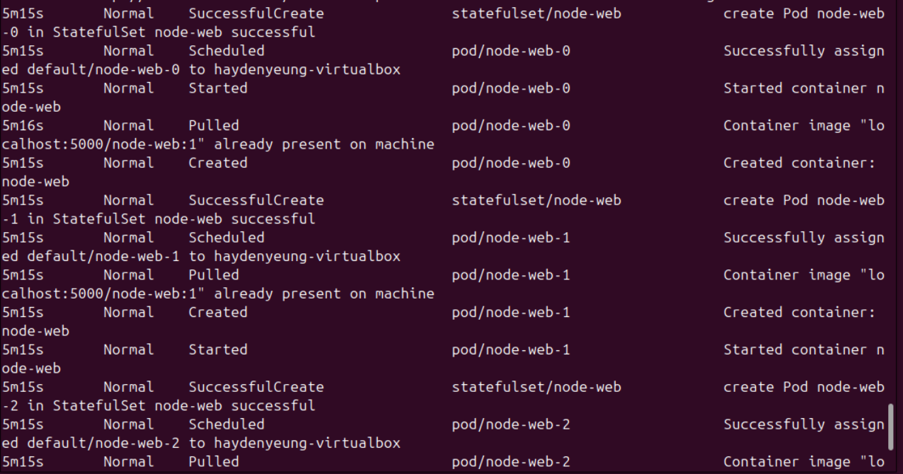

Results:

* All 3 generated pods from applied “stateful-web.yaml” were healthy.
* However, before this result: the set values for probe above caused K8s to considered these 3 pods unhealthy – because probe did the checking before the pods ran (applications in these pods were not yet opened port 8080).

Tested with the following commands:

* Because in the content of the corrected version of “stateful-web.yaml”, the “kind” value was changed from “Deployment” to “StatefulSet” → There was no deployment to be found.
* A StatefulSet named “node-web” was found instead. Service and pods were found because the new version of “stateful-web.yaml” still using the same Service specs → the same with the case of pods.

“kubectl describe statefulsets node-web”

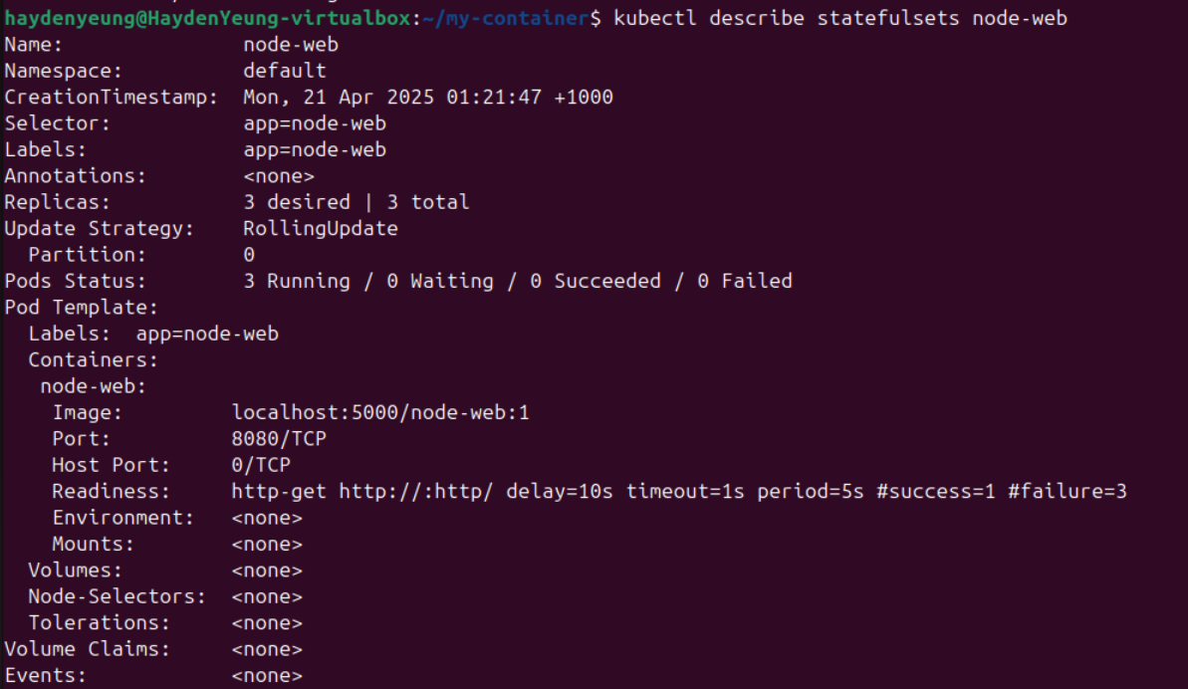

“kubectl describe pod node-web-0”

* In “pod node-web-0”, I could see the line “Controlled By: StatefulSet/node-web”.

Try to Delete a pod through: “kubectl delete pod node-web-0”

* Pod “node-web-0” was recreated instead of a new pod name like in the case of Deployment.

Try to splitting a pod from the StatefulSet node-web through command: “KUBE_EDITOR='nano' kubectl edit pod node-web-0” and change the value of “label” from: “app: node-web” to “app: task61p”

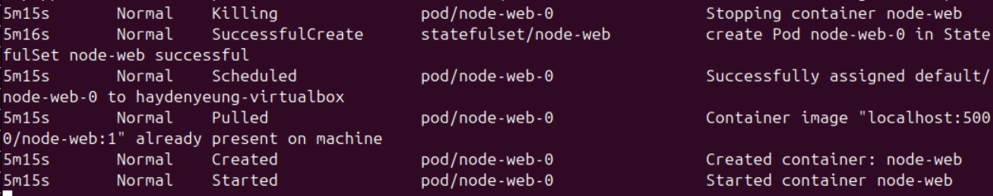

* This pod “node-web-0” was destroyed and recreated instead of being splitted to be an outsider like in Deployment scenarios.

Modified the original “myapp.js” file

Add the following code to “Container” spec in “stateful-web.yaml” and change the image name from localhost:5000/node-web:1 to localhost:5000/node-web:4 (despite that I forgot to change the v1 to v4 inside the context of “myapp.js”).

“kubectl apply -f stateful-web.yaml”

* Each pod has its own PVC.

“kubectl exec -it node-web-0 – sh -c “date > /data/datestamp.txt” & “kubectl port-forward node-web-0 8080:8080”

Testing with data storage of node-web-0

* /data/test.txt only presents in node-web-0 but not in other pods.
* Data still persisting after the original node-web-0 is deleted and “equipped” back on the new recreated node-web-0 (automated by StatefulSet).

3. Quiz Result

